Software Requirements Specification

for

Electronic Medical Information System (EMIS)

Prepared by: Sergio Falcon

Daniel Greenless

Jae Seo

Sanjay Nadaraja

John Callaway

Octorber 30, 2016

Table of Contents

Table of Contents 1

Table of Figures 1

List of Tables 1

1. Introduction 2

1.1 Purpose 2

1.2 Scope 2

1.3 Acronyms, abbreviations, notational conventions 2

1.4 Overview 2

1.5 References 2

3. Specific Requirements 3

3.1 Functional Requirements 3

3.1.1 Use Case Diagrams and Description 3

3.1.2 Class Diagrams and descriptions 13

Table of Figures

Figure 1: Use Case Diagram 4

Figure 2: Class Diagram 6

Figure 3: GUI Login 7

Figure 4: GUI Patient Main - “View Medical Record” 8

Figure 5: GUI Patient - Select Medical Record 9

Figure 6: GUI Patient - View Medical Record 10

Figure 7: GUI Patient Main - “Add Medical History” 11

Figure 8: GUI Patient - Add Medical History 12

Figure 9: GUI Patient Main - "Update Personal Information" 13

Figure 10: GUI Patient - Update Personal Information 14

Figure 11: GUI Patient Main - "Update Insurance Information" 15

Figure 12: GUI Patient - Update Insurance Information 16

Figure 13: GUI Patient Main - "Schedule Appointment" 17

Figure 14: GUI Patient - Schedule Appointment 18

Figure 15: GUI Patient Main - "Message Clinic" 19

Figure 16: GUI Patient - Send Message 20

Figure 17: GUI Patient Main - "View/Pay Bill Online" 21

Figure 18: GUI Patient - View/Pay Bill 22

List of Tables

No table of figures entries found.

# Introduction

## Purpose

This Software Requirements Specification document has been created in order to guide the software development team in creation of the Electronic Medical Information System (EMIS) and allow stakeholders to view the design aspects. It describes in detail who will be able to use the system and the functionality of what can be performed by each user.

## Scope

The software being created is called the Electronic Medical Information System(EMIS). It will provide patients, doctors, nurses, clinical staff, insurance agencies, pharmacies, and lab facilities a way to communicate with greater efficiency and security than current paper methods. A patients medical history and current care will all be consolidated to a single system that allows selected access to view what each party member requires. It will not replace physical visits between a patient and doctor. The EMIS will allow documentation of all sorts, including scanned images, audio recordings, prescriptions, lab orders, vital readings, diagnosis’, and medical history to be accessed remotely.

## Acronyms, abbreviations, notational conventions

## Overview

*The rest of this document contains the functional requirements for the EMIS. It contains a Use Case Diagram with a description and detailed table description for each identified use case. There is also a Class Diagram and description for how the different facets of the software will interact within the system.*

## References

IEEE Computer Society. Software Engineering Standards Committee, and IEEE-SA Standards Board. "IEEE Recommended Practice for Software Requirements Specifications." Institute of Electrical and Electronics Engineers, 1998.

# Specific Requirements

## Functional Requirements

### Use Case Diagrams and Description

Figure 1 shows the Use Case Diagram for the EMIS system. The first use case, UC-01: Login, is connected to every other use case through the <<includes>> relationship. All actors must first succesfully login before performing any other actions within the system. Our diagram also shows that the Clinical Staff is a child of the Patient actor, as well as the Doctor is a child of the Nurse actor. Both the Clinical Staff and Doctor actors are able to perform any of the actions of their parents in addition to their own individual options. The “AddLabResults”, “AddDiagnosis”, and “AddMedicalCondition” are connected to “UpdateMedicalRecord” via the <<includes>> relationship as well because it must be updated each time they are submitted. This also happens with the “BillingApplication” and <<includes>> relationship between “PayPatientBill”, and “PayInsuranceBill”. Using the Time actor, the “SendAppointReminder” can be actived as an extension of the “ScheduleAppointment” use case.

Figure : Use Case Diagram

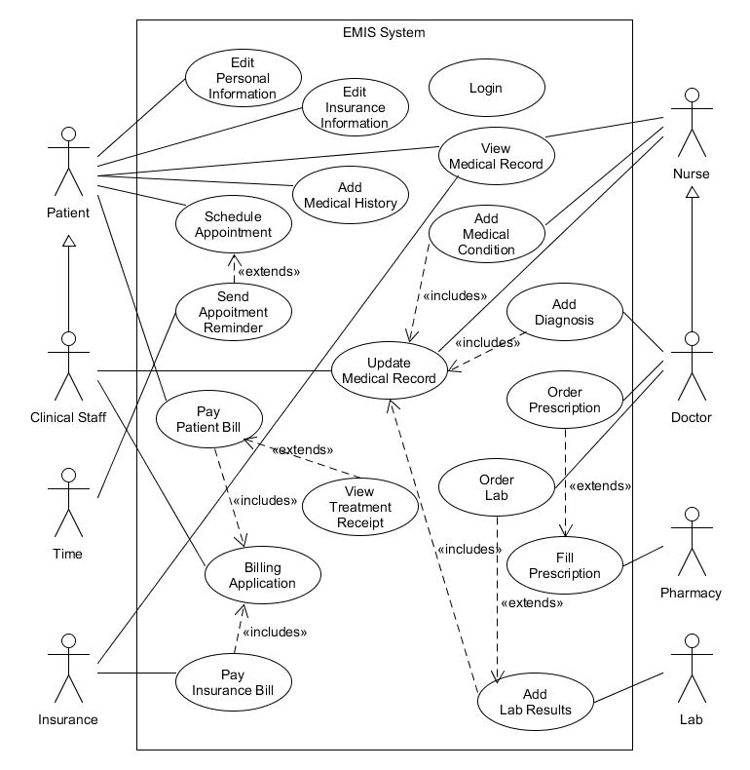

### Class Diagrams and descriptions

Figure 2 shows the Class Diagram for the EMIS system. It gives a more detailed description of how the classes and features of the EMIS will interact with each other and the users of the system. All information and interactions are connected to the MedicalChart. It can store multiple medical records, each which contains information from a patient visit. A patient will have multiple medical records as the doctors, nurses, and clinical staff update the system with information about the patient. A medical record will have information relating to vitals, diagnosies, prescriptions, lab results, receipt of treatments performed, and medical history. It can also include any physical documentation or photos scanned into the system as well as audio recordings. The patient, clinical staff, nurse, and doctor will be allowed varying access to the medical chart. Doctors are allowed to submit diagnosis, order tests and prescriptions, but the patient can only view this information after the medical record has been submitted. The pharmacy and lab will have access to both the prescription information, insurance information, and personal information in order to bill the proper parties for their services. Clinical staff and patients can access the message system in order to schedule appointments which are added to the doctor’s calendar. Time will monitor when a patient’s appointment is drawing near and send a reminder through the messaging system to the patient. The billing system allows the clinical staff to bill both the insurance and patient directly. If the patient is covered by insurance, they can submit just the co-pay amount rather than the full billed amount of services rendered.

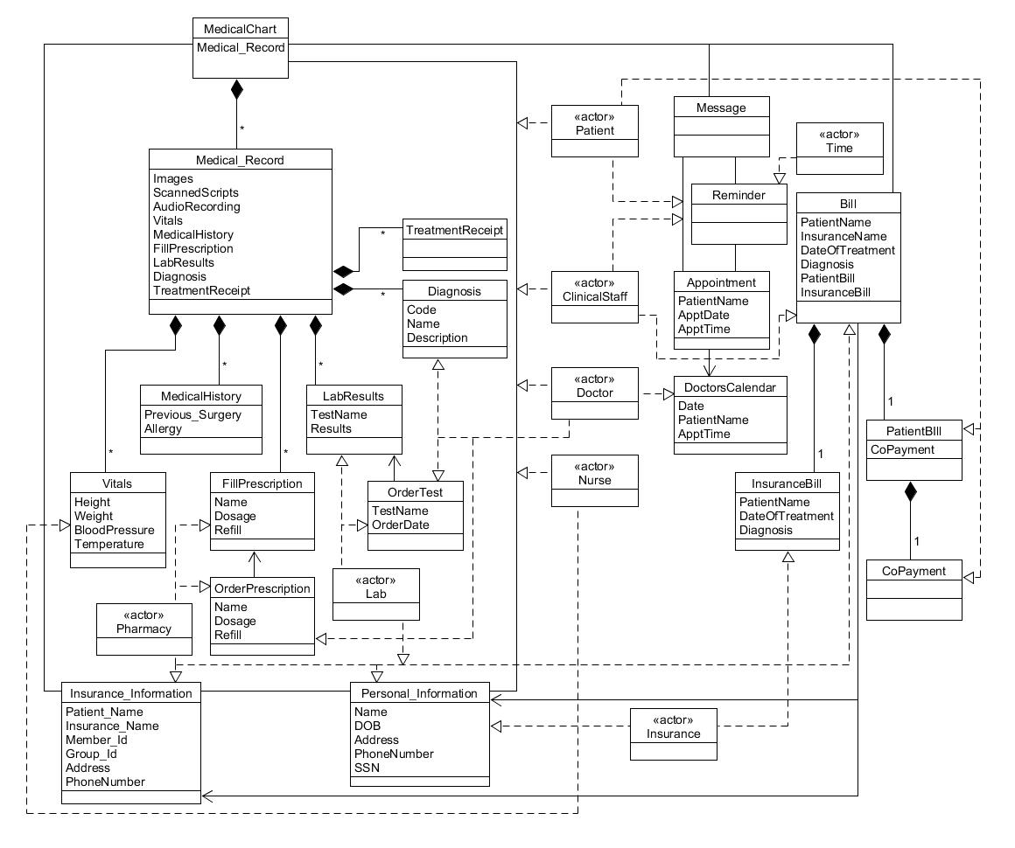

Figure : Class Diagram

### GUI Screenshots and Walkthrough

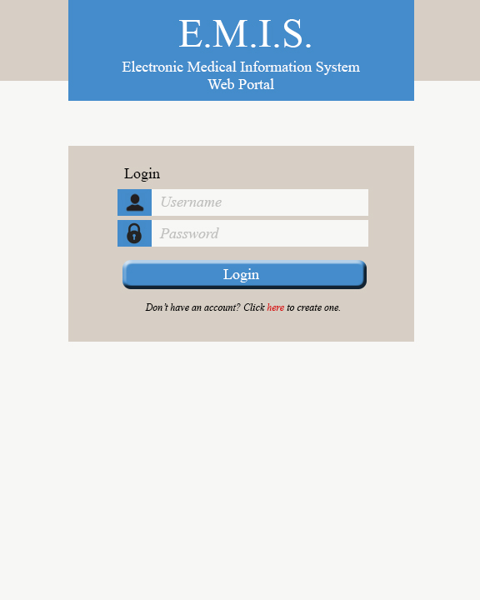This is the main login page. The user will enter their username and password then click the Login button. If the user does not have an account, they can click the link below the login button to request a new account.

Figure : GUI Login

After the login button is clicked, the main page will load. The main page is unique for each of the account types: Patient, Clinical Staff, Nurse, Doctor, Pharmacy, Laboratory, and Insurance. We’ll follow the patient options first.

Patient Main: User clicks on “View Medical Record”

Figure : GUI Patient Main - “View Medical Record”

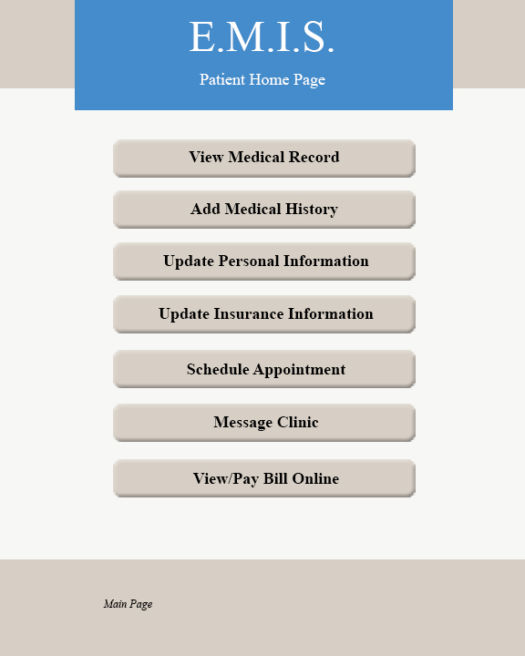

A listing of medical records will be shown by date to the patient. Then a date is clicked and selected.

Figure : GUI Patient - Select Medical Record

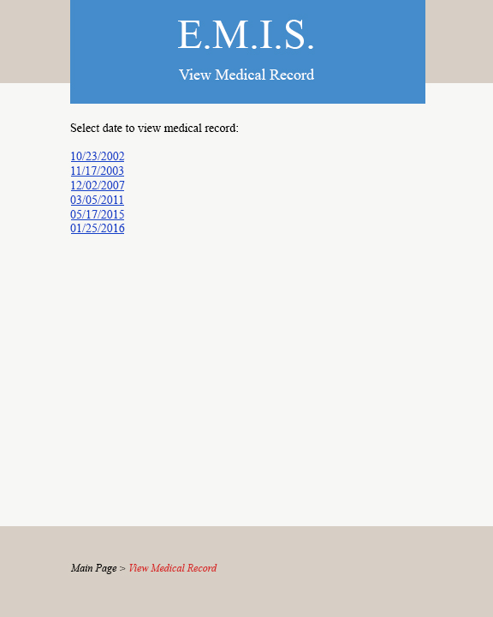

The medical record for the date chosen is shown in detail. The patient can view the information but cannot change any details. At the bottom, they can then click the “Main Page” link to return to the patient main page.

Figure : GUI Patient - View Medical Record

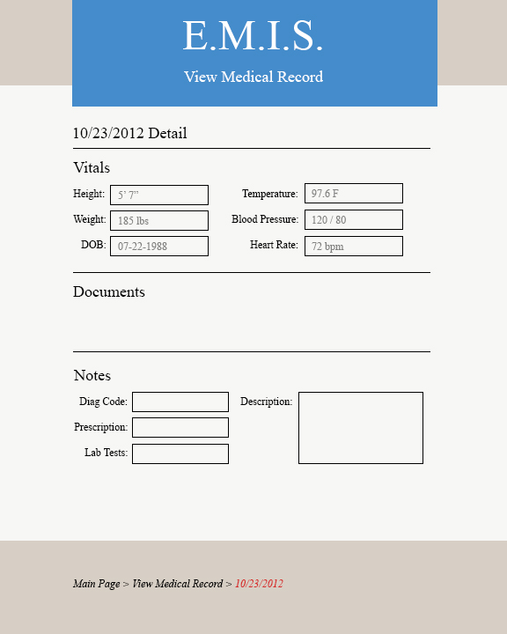

The patient can also select “Add Medical History” to add past events as a medical record into their medical chart.

Figure : GUI Patient Main - “Add Medical History”



In this section, the patient enters the date of the history item, the description of the surgery, visit, or treatment, and upload any additional documentation they may have. Clicking the “Submit History” button will add the item to the database and return the user to their main page.

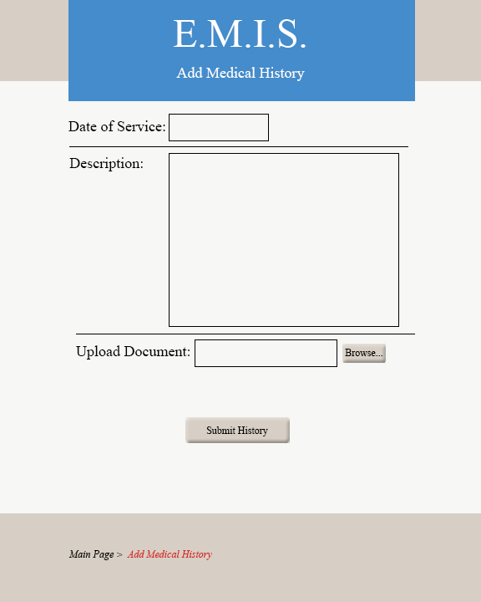

Figure : GUI Patient - Add Medical History

The patient clicks “Update Personal Information”.

Figure : GUI Patient Main - "Update Personal Information"



Here the patient can view all their personal information and update anything as needed. When complete, they can click “Submit Updates” which will update the database and take them back to the main page.

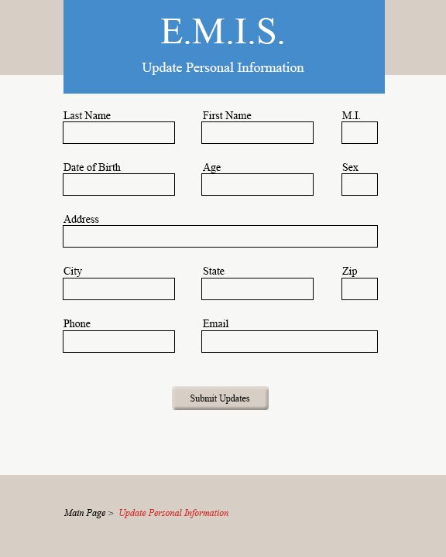

Figure : GUI Patient - Update Personal Information

The patient selects “Update Insurance Information”.

Figure : GUI Patient Main - "Update Insurance Information"



The patient can view or update their insurance information. When “Submit Updates” is clicked, they care taken back to the main page.

Figure : GUI Patient - Update Insurance Information

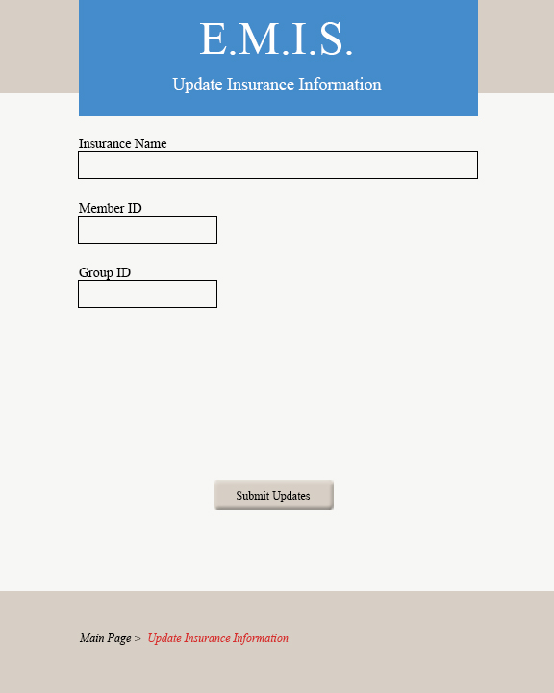

The patient selects “Schedule Appointment” from the main page.

Figure : GUI Patient Main - "Schedule Appointment"



The enters their name, reason for visit, and the doctor they’d like to see and clicks “Submit Request”. An email is then sent to the clinical staff who can find an opening on the calendar.

Figure : GUI Patient - Schedule Appointment

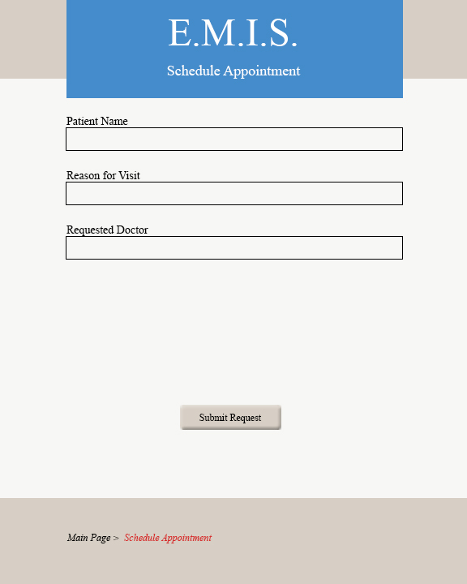

The patient clicks on “Message Clinic”.

Figure : GUI Patient Main - "Message Clinic"



The patients enters their name, a message, then clicks on the “Send Message” button and they are returned to the main page. An email is sent with the information to the clinical staff.

Figure : GUI Patient - Send Message

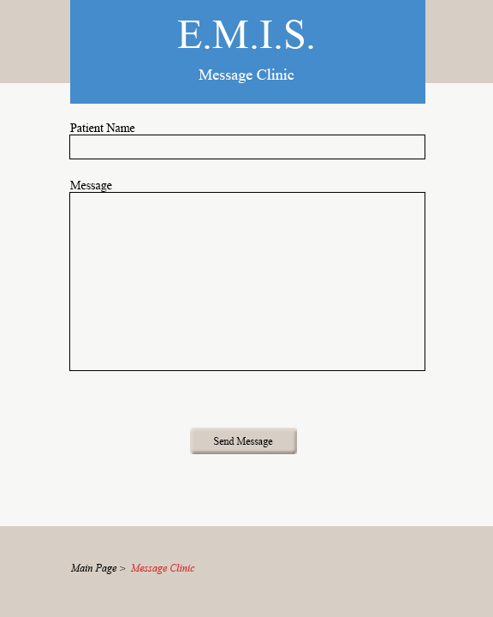

The patient clicks “View/Pay Bill Online”.

Figure : GUI Patient Main - "View/Pay Bill Online"



The patient can view all pending charges for their account. Then they can enter credit card information and pay those charges by clicking the “Submit Payment” button which then takes them back to the main page.

Figure : GUI Patient - View/Pay Bill

